**EXPLORING WORLD’S TOP YOUTUBE CHANNEL**

**1.INTRODUCTION**

**1.1 OVERVIEW:**

*A subscriber to a channel on the video -sharing You Tube is a user who has chosen to receive the channel's content by clicking on that channel's "subscribe" button ,and each user's subscription feed consists of videos published by channels to which the user is subscribed. The ebility to subscribe to users was introduced in October 2005. You Tube began published a list of its most-subscribed channels in April 2006. An early archive of the list dates to may 2006. The following table lists the 50 most-subscribed YouTube channel's as well as the primary language and content category of each channel*.

**1.2 PURPOSE:**

*You can watch and like videos and subscribe to channels with a google account. But without a YouTube channel, you have no public presence on youtube. Even if you have a google account, you need to create a youtube channel to upload videos, comment are make playlists.You can use You Tube for learning. You Tube is a platform for learners. You can learn anything from anyone ,be it a chef or an expert, everything is accesible on youtube. Also, you can learn almost anything like English, Coding, Business management, and so much more.*

**2.PROBLEM DEFINITION AND DESIGN THINKING**

**2.1 EMPATHY MAP :**

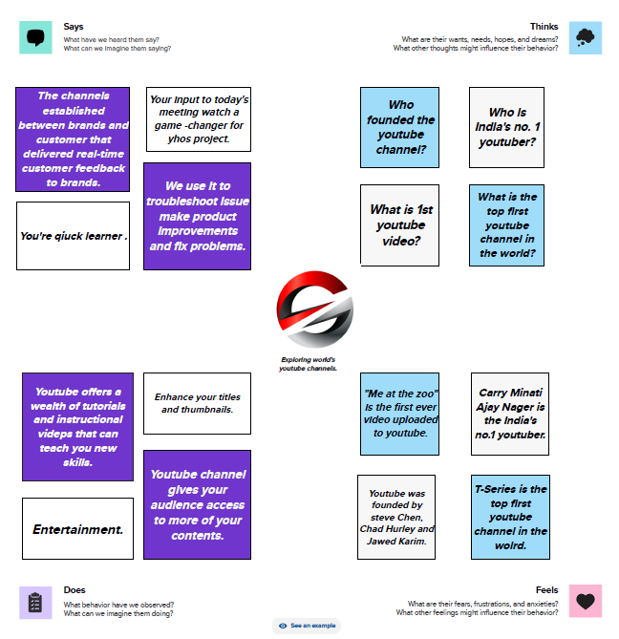

**2.2 IDEATION & BRAINSTORMING MAP:**

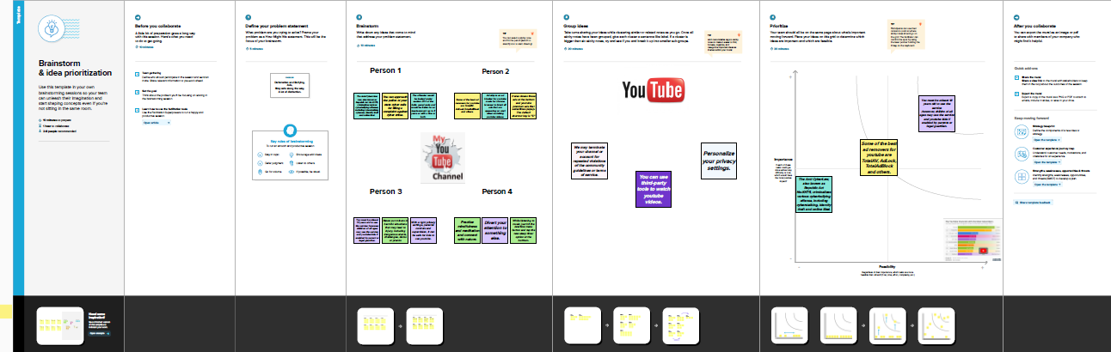

**3.RESULT**

**3.1 DASHBOARD**

*A**dashboard is a graphical user interface (GUI) that displays information and data in an organized, easy –to –read format. Dashboards are often used to provide real –time monitoring and analysis of data, under typically designed for a specific purpose or use case. Dashboards can be used in a variety of settings, such as business, finance , manufacturing, healthcare ,and may other industries .They can be used to track key performance indicators (KPIs), monitor performance metrics, and display data in the form of chats, graphs, and tables.*

**Dashboard 1**

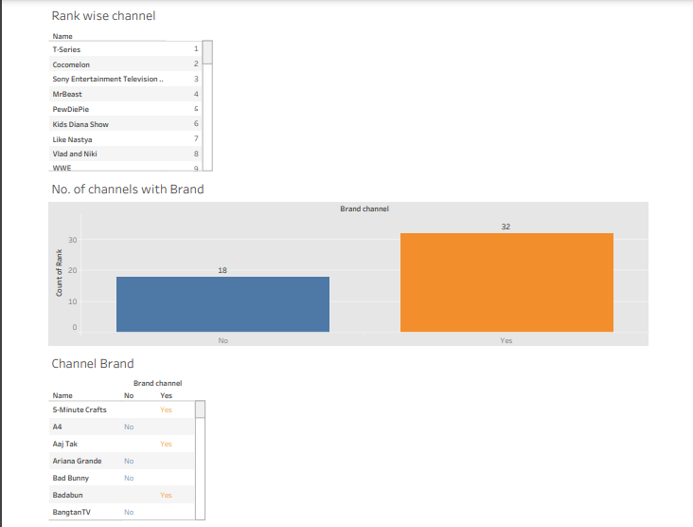

**Dashboard 2**

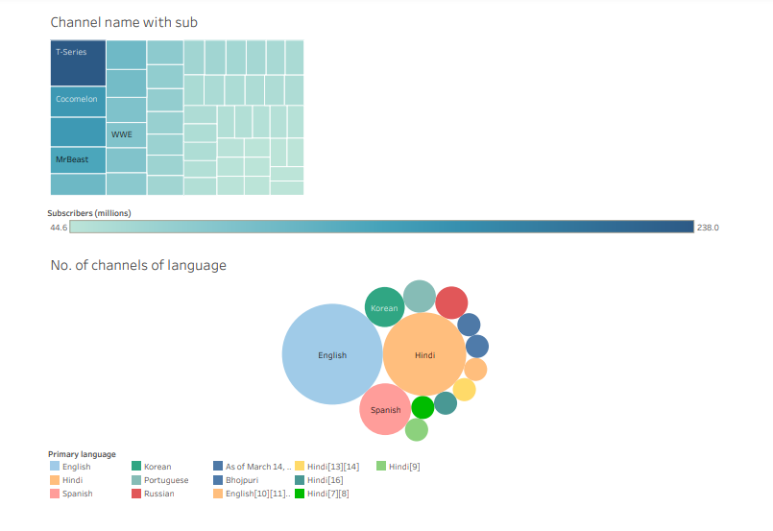

**Dashboard 3**

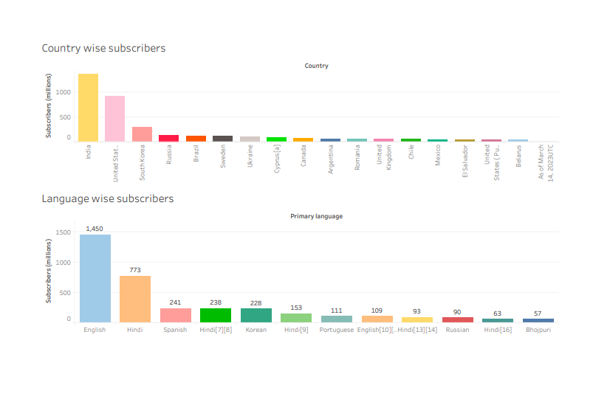

**Dashboard 4**

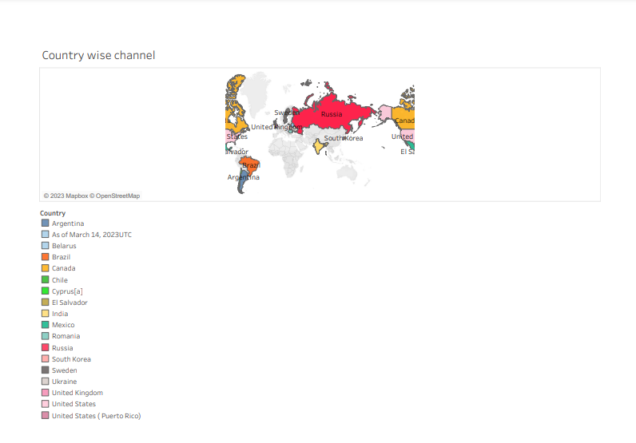

**3.2 STORY**

*A data story is a way of presenting data and analysis in a narrative format, with the goal of making the information more engaging and easier to understand. A data story typically includes a clear introduction that sets the stage and explains the context for the data, a body that presents the data and analysis in a logical and systematic way, and a conclusion that summarizes the key findings and highlights their implications. Data stories can be told using a variety of mediums, such as reports, presentations, interactive visualizations, and videos.*

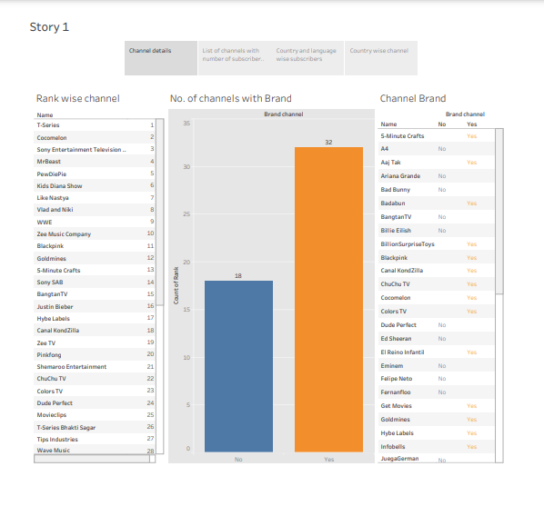

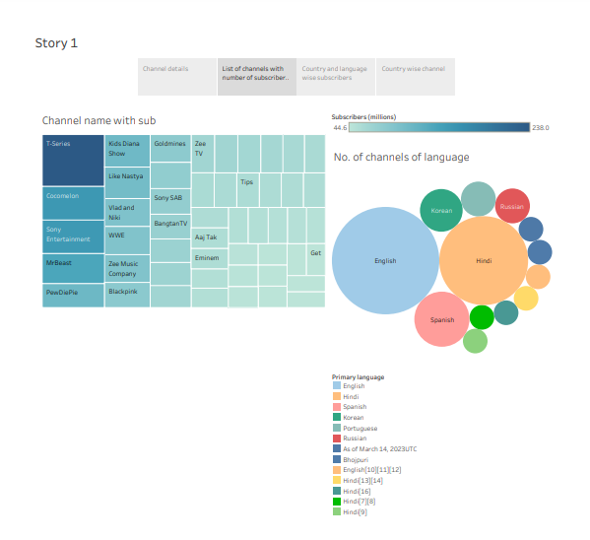

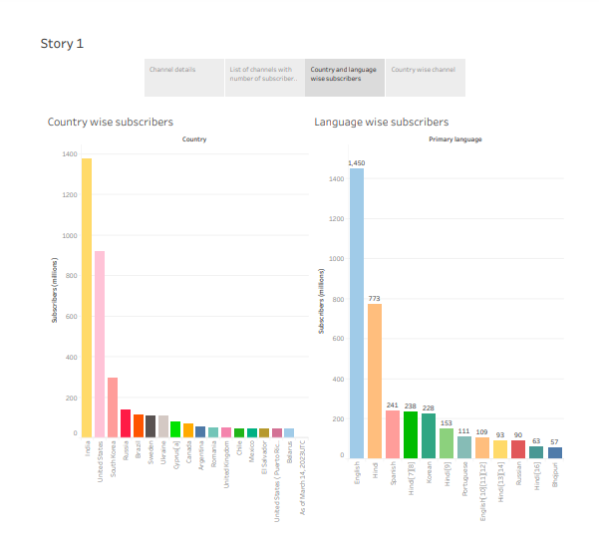

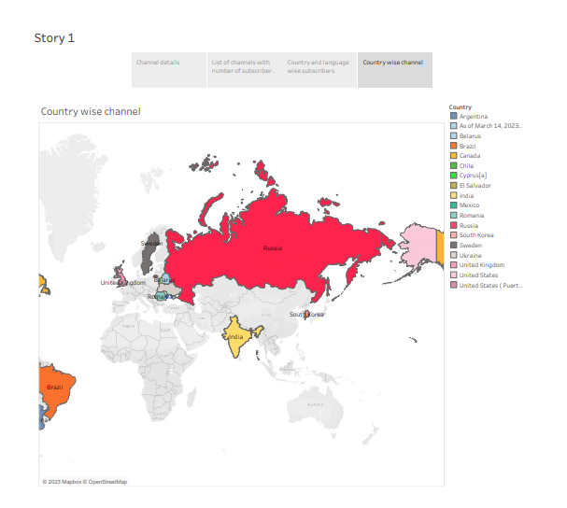

**ADVANTAGES:**

*When it comes to digital marketing, there are a multitude of platforms for you choose from. While popular sites such as Facebook, Instagram, are your company’s website are great places to invest in, having a youtube channel might just be the best place to promote your business on there.*

**DISADVANTAGES :**

*Since You Tube is a no-cost and accessible platform for anyone, children are attracted to watching videos with explicit language and obscenity. The use of explicit images and words is common nowadays.*

**APPLICATIONS:**

*YouTube is a video sharing service where users can watch, like, share, comment and upload their own videos.*

*The combination of visuals and audio-along with youtuber’s content culture of simple, digestible messaging-makes youtube videos a great tool for engaging students in learning. In fact, 91% of educational institutions say video increases student satisfaction.*

**CONCLUSION:**

*Youtube allows you to showcase your brand uniquely by creating your channel. You can use this platform as a place to share valuable content that builds trust with potential customers and showcase your products in action.*

**FUTURE SCOPE:**

*In India, a YouTuber with a decent number of subscribers on their YouTube channel can earn 25,000 INR per month. Additionally, a YouTuber with a few million subscribers and a few million views on their content can earn lakhs. The view count is extremely crusial for deciding how much money a Youtube video can make .*